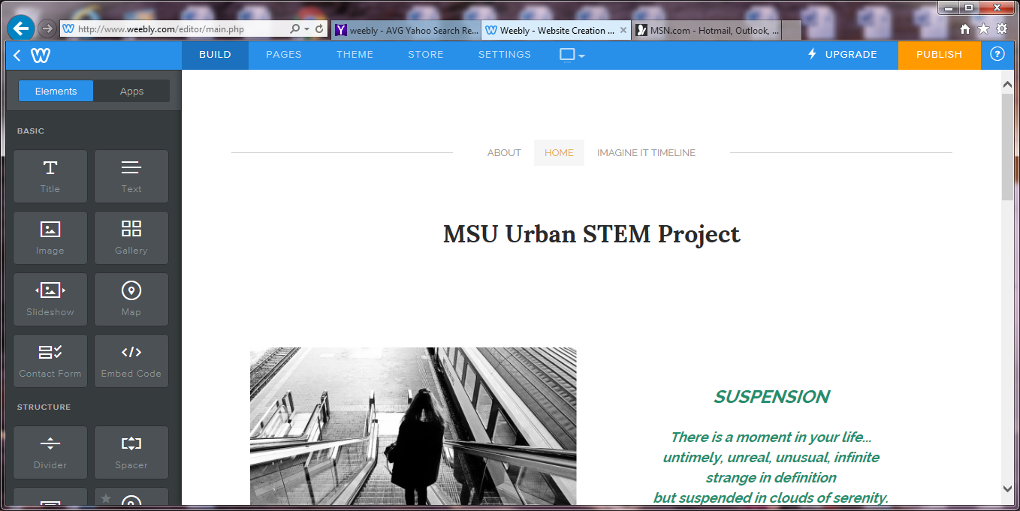

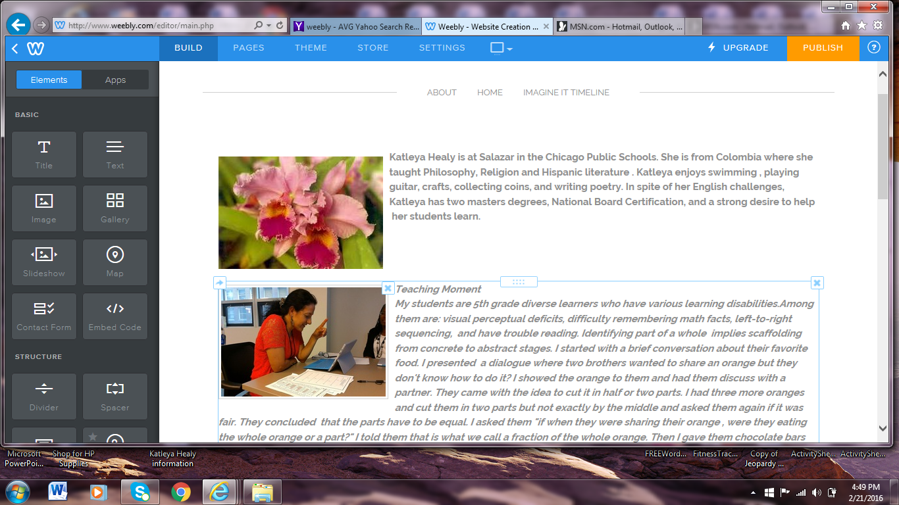

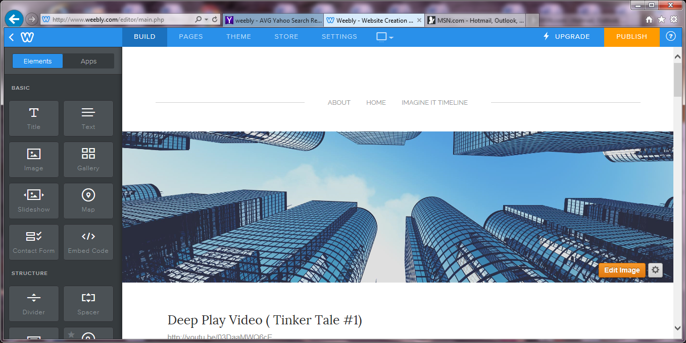

To my amazement, I discovered that I do have a digital presence. Before the MSU Stem project, I had never used Facebook, twitter, or had my own website. My public profile on social media contains little information about my private life except for my current address and a brief note about St. Barbara parish to which I belong. My profile is a combination of information about my achievements, grants, projects and leadership positions I have taken during my work as an educator. Among those achievements are becoming a National Board Certified Teacher and being supported in the certification process by CTU ‘s Quest Center ; being a group member of two CFE small grants and two Oppenheimer Family Foundation grants for Science/Math and Technology “Discover the World of Microbiology” and for Language Arts “ Reading is Success”. As a leader, in creating a Crypto Club and a Math Club at the school as well as being an elected member of the LSC (Local School Council). Some of the projects which I have been part of have been the MSU Urban Stem with my Imagine IT Project on Global Issues and the Artsonia project, where my students took part in showcasing artists, interests, talents and dreams. Finally, as a writer I am mentioned in the current edition of the book “The Ultimate Stem”.

